**QUESTION 1.**

To download and install Windows 11, you follow these steps:

1. Check system requirements to ensure your device meets the minimum system requirements for Windows 11. You can check these requirements using the PC health check app and verify that your device has a 64-bit CPU and at least 4 GB of RAM for a smooth experience.
2. Download Windows 11, go to the Microsoft website and click on the download Windows 11 button. Choose the option to download the Windows 11 installation assistant or the media creation tool. (Use the link, <https://www.microsoft.com/software-download/windows11>, on any browser of choice: Google Chrome, Microsoft Edge, or Firefox.
3. On the installation assistant, select the download now button for the installation assistant to run the tool as an administrator. Confirm your device hardware is compatible, accept the license terms, and install Windows 11. Follow the prompts to complete the installation which may involve restarting your pc several times.
4. On the media creation tool, you can choose the Create Windows 11 installation media option download the media creation tool run the tool as an administrator select the language edition and architecture 64-bit for Windows.
5. On using a bootable USB flash, you choose to create a bootable USB flash drive or iso file follow the prompts to complete the installation media creation process, install Windows 11 insert the USB flash drive or DVD containing the installation media restart your PC and select the USB drive or DVD as the boot device follow the installation prompts to install windows 11 which may involve selecting the language time and keyboard preferences and then choosing to install windows.
6. Post installation ensure you have backed up your data before installing Windows 11. Check for updates and install any necessary drivers for your hardware. Following these steps, you can download and install Windows 11 on your device.

To troubleshoot steps when installing Windows 11, you follow these steps :

1. Check compatibility and run the PC health check to ensure your PC meets the minimum system requirements for Windows 11 this includes TPM 2 0 and compatible CPU models.
2. Check system requirements and verify system requirements to ensure your device meets the minimum system requirements for Windows 11 if not you may need to upgrade your hardware or consider alternative solutions.
3. Disable antivirus and VPN disable antivirus and VPN temporarily disables antivirus software and VPNs to prevent interference during the installation process.
4. Do a clean install if the installation fails try downloading the Windows 11 iso and creating a bootable USB drive ensure the USB drive is formatted as ex fat 32 and split large files if necessary.
5. Update storage driver: Ensure your storage driver is up to date, this can resolve issues with the installation process.
6. Check for known issues check by visiting the Windows release health hub to check for known issues that might affect your device.
7. Use the installation assistant use If you're upgrading from Windows 10. Use the installation assistant to upgrade to Windows 11 this ensures a smooth transition and helps resolve any compatibility issues.
8. Create a Windows 11 installation media bootable USB drive using the Windows 11 software download page this allows you to install Windows 11 from the media.
9. Troubleshoot specific issues if you encounter specific issues such as the Windows installation has failed error refer to the troubleshooting guides provided by Microsoft and other sources.
10. Seek support if none of the above steps resolve the issue seek support from Microsoft or other reliable sources, they can help you troubleshoot and resolve the problem.

By following these steps, you can troubleshoot and resolve common issues encountered during the installation of Windows.

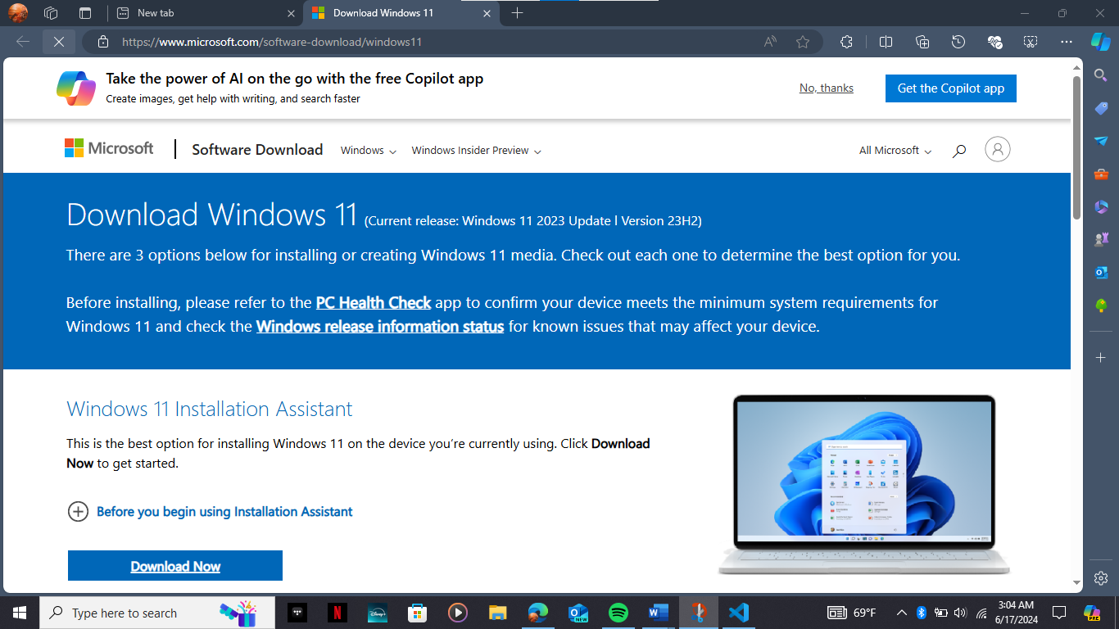

**QUESTION 2.**

To install a text editor or integrated development environment, you do the following:

**Windows**

1. Download VSCode:

2. Go to the  [VSCode download page](https://code.visualstudio.com/Download) through the link: <https://code.visualstudio.com/Download>,

3. Download the installer for Windows (VSCodeUserSetup-{version}.exe).

4. Install VSCode:

5. Run the installer (VSCodeUserSetup-{version}.exe).

6. Follow the instructions to install VSCode.

7. Launch VSCode:

8. Open a new terminal and type code to open VSCode.

To troubleshoot issues encountered during the process of installing or using Visual Studio code, follow these steps :

1. Ensure you have the latest version of vs code or check your are vs code version to ensure you are running the latest version update vs code if you are not running the latest version update to the latest release by running help check for updates on Linux and windows or code check for updates on mac os.

2. Verify your shell and operating system use the latest shell version ensure you are running the latest version of your shell for example if you are on an older version of Windows 10 consider upgrading to a newer version check your operating system and ensure your operating system is up to date especially if you are on an older build.

3. Enable trace logging trace this can help identify the problem by recording all arguments used to create the terminal process and keeping the log for later reference if the issue persists.

4. Additional troubleshooting steps report the issue if none of the above steps help report the issue to Microsoft support for Visual Studio 2022, collect setup logs, and use the Visual Studio feedback tool for Visual Studio 2019 and previous versions to collect setup logs and attach them to the report.

1. Try repairing or reinstalling if the issue persists, visual studio checks known issues see if the issue is a known problem and check for workarounds in the Visual Studio developer community.
2. Use portable mode if you cannot install vs code, consider using the portable mode this allows you to run vs code from a USB drive or a network share without installing it on the local machine.
3. Refer to the vs code documentation for detailed information on troubleshooting and using the integrated terminal visual studio installation troubleshooting follow the steps in the visual studio installation troubleshooting guide to resolve common issues with visual studio installation and upgrade.

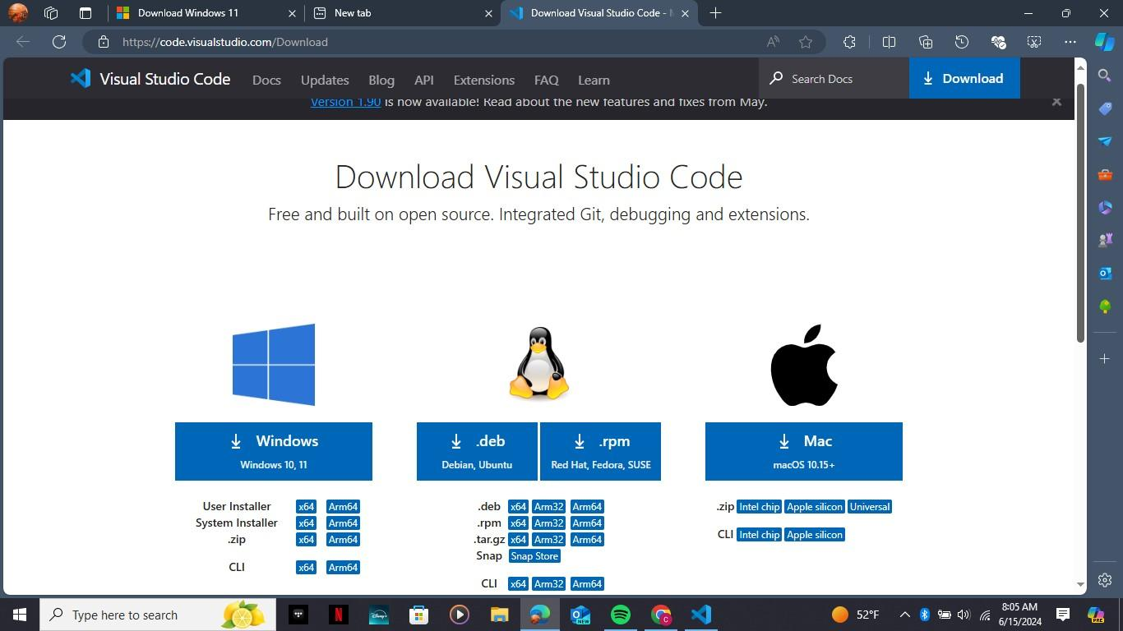

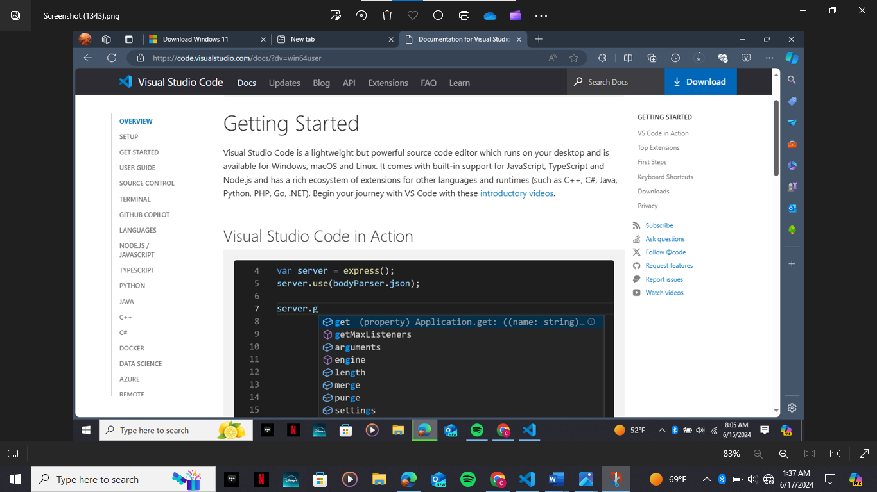

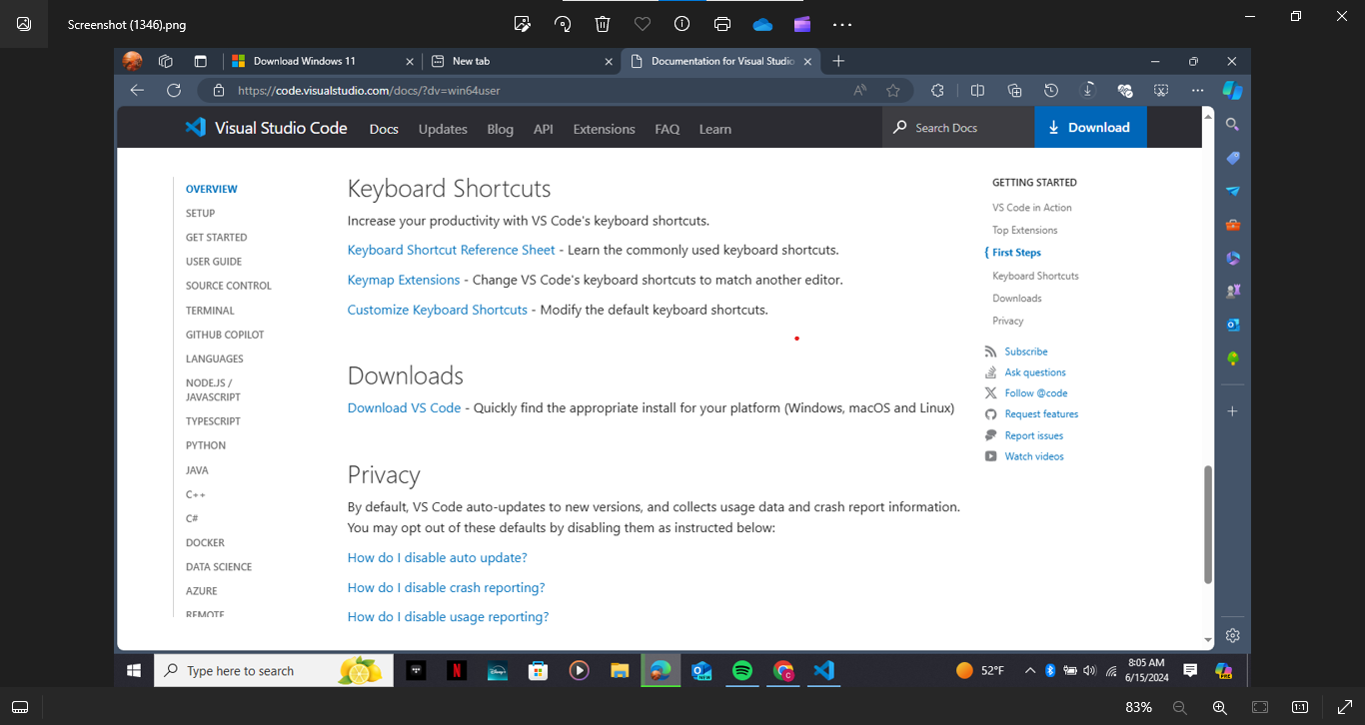

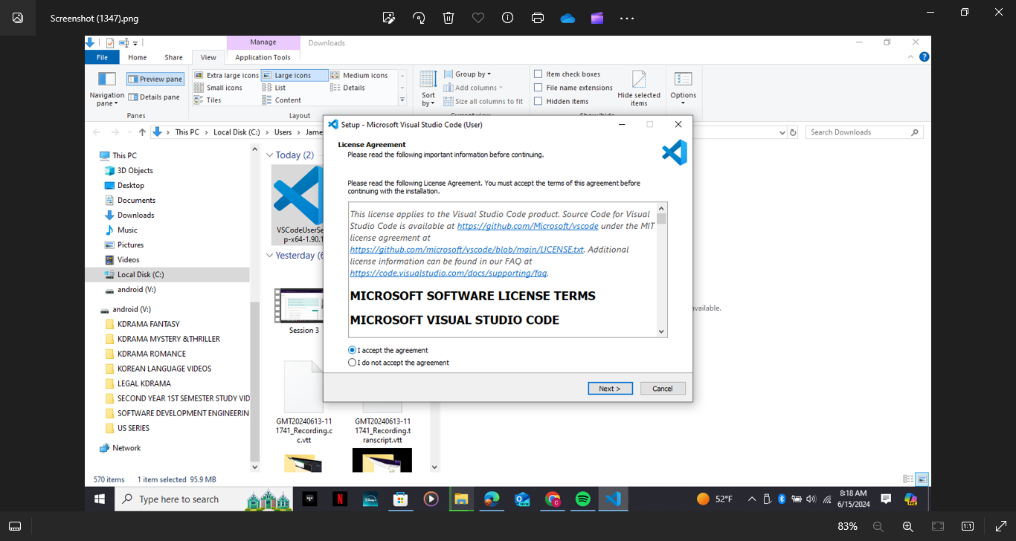

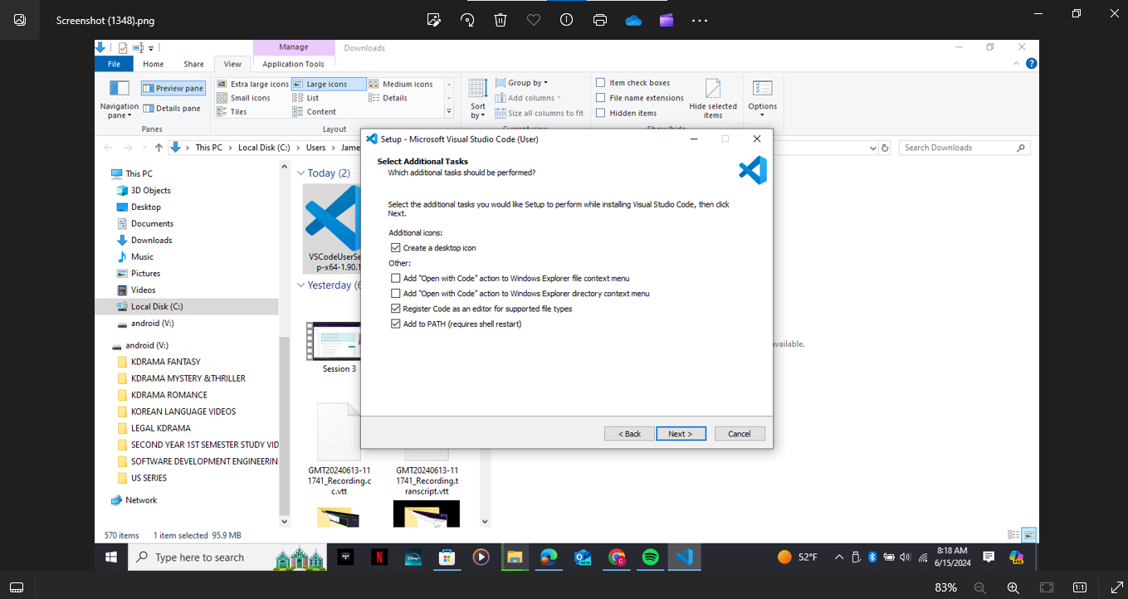

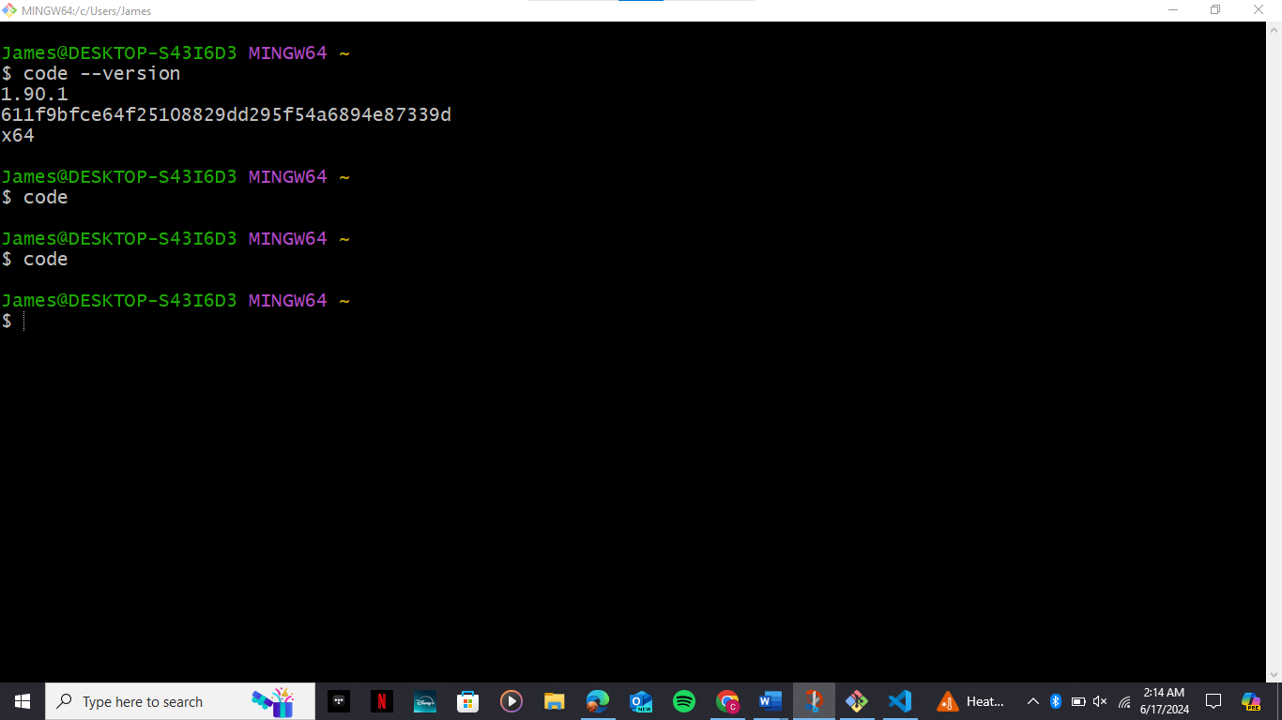

**QUESTION 3**

To set up a version control system follow these steps:

1. Install git download and install git download the git installer from the official git website and follow the installation instructions for your operating system.
2. Configure git to set the username and email use the git config global user name and git config global user email commands to set your username and email address this helps identify you as the author of commits.
3. Create a git hub account sign up for git hub visit the git hub website and create an account fill in the required information including your email password and username.
4. Initialize a git repository and create a new repository navigate to the directory where you want to initialize your git repository and run the command git init to create a new git repository.
5. Make your first commit add files to the repository use the git add command to stage the files you want to include in your repository then use the git commit command to commit these changes with a meaningful commit message.
6. Associate a text editor with git, choose a text editor select a text editor like Visual Studio Code sublime text or text mate configure git to use this editor by running the git config global core editor command with the path to the editor’s executable.
7. Verify your setup verify your git installation open a terminal and run the command git version to ensure git is installed correctly verify that your username and email are set by running git config global user name and git config global user email.
8. Explore git and git hub explore git commands and familiarize yourself with basic git commands like git status git log and git branch learn how to create branches merge changes and resolve conflicts explore git hub features learn about git hub features like repositories issues pull requests and collaborators understand how to create and manage repositories and how to collaborate with others on projects.

By following these steps you will have successfully set up a version control system using git and git hub.

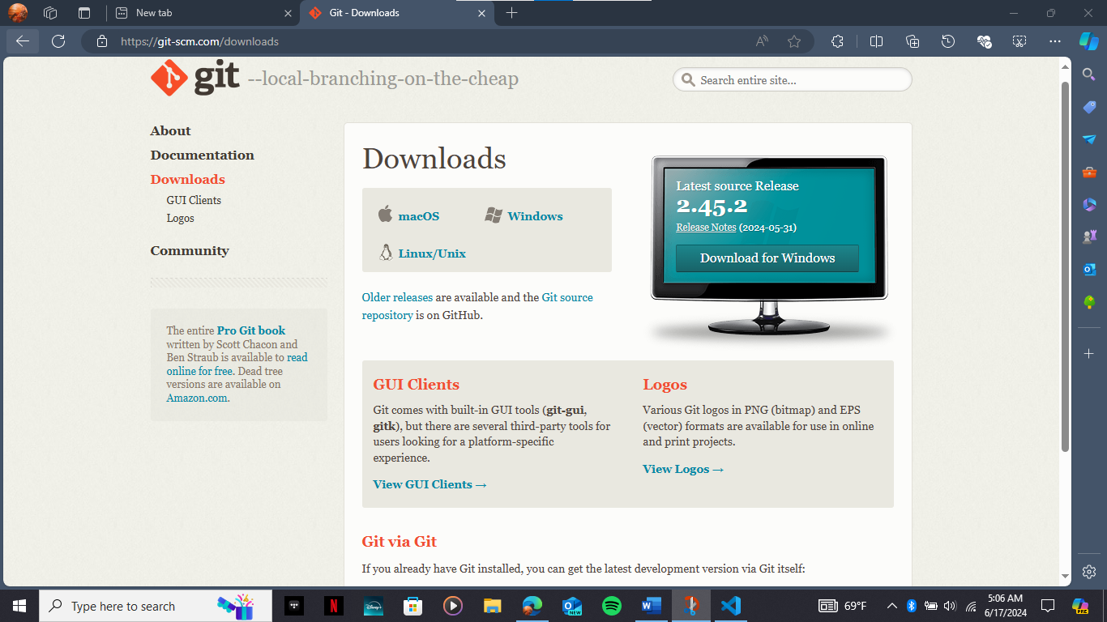

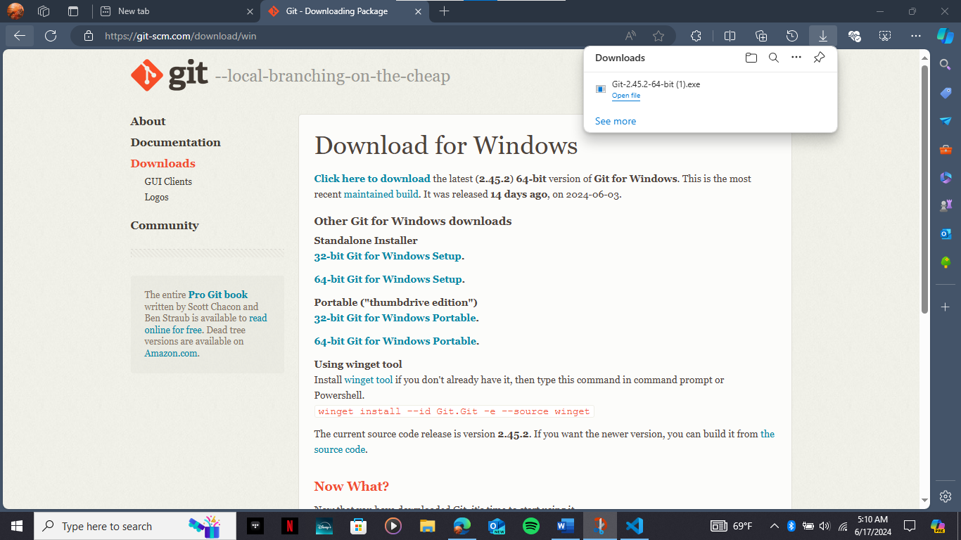

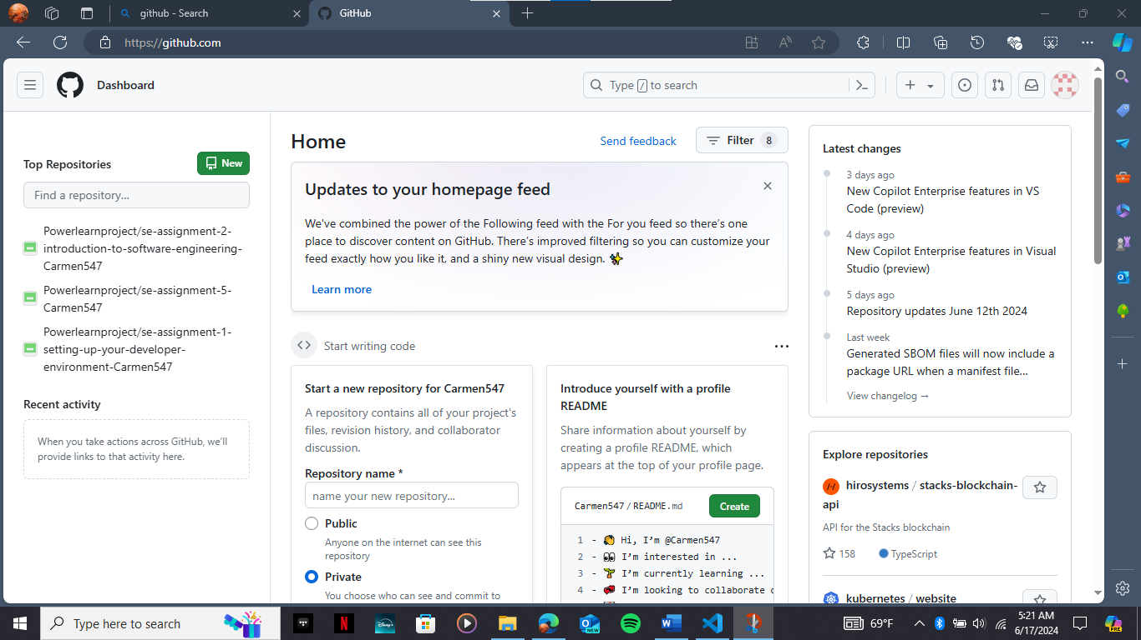

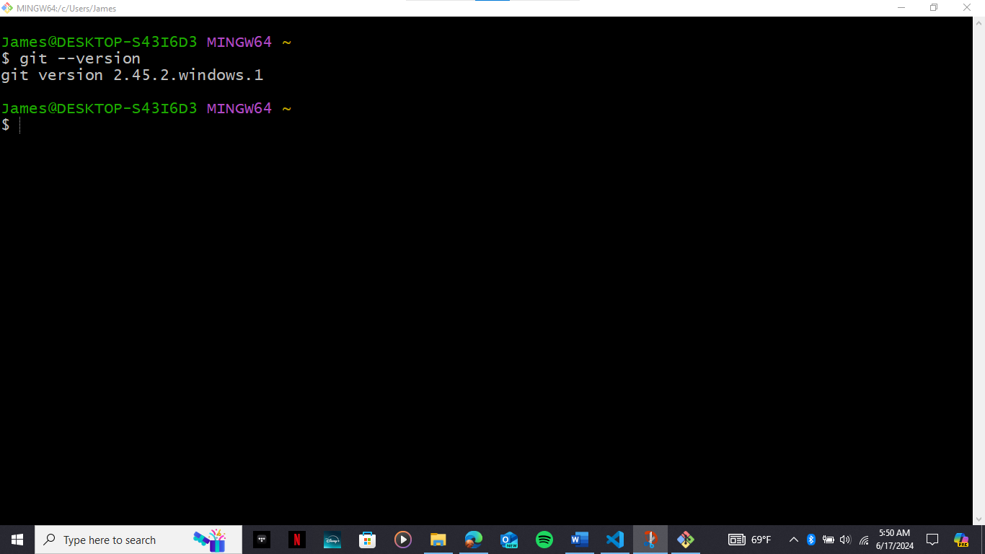

QUESTION 4

To install Python, follow these steps:

1. Go to the official Python download page at <https://www.python.org/downloads/>, At downloads choose the latest version of Python for your system either windows, mac os or Linux
2. Install Python for Windows Download the Python installer 64-bit or 32 bit depending on your system architecture run the installer by double-clicking the downloaded file follow the prompts to install Python ensure you select the options to install the launcher for all users and add Python to the path for mac os and Linux download the python installer from the official website run the installer by double clicking the downloaded file follow the prompts to install python.
3. Verify Python installation open a command prompt or terminal type Python version to confirm that Python has been installed correctly.
4. Set up Python environment for beginners it is recommended to install Python from the Microsoft store on Windows this method handles path settings for the current user and provides automatic updates. For more advanced users you can download and install Python directly from the official website which allows more control over the installation process.
5. Choose an integrated development environment ide popular choices include py charm visual studio code and ide each has its own features and user interface so choose the one that best suits your needs.
6. Write and run Python code use your chosen ide to write and run python code for simple programs you can also use a text editor like Notepad and run the code from the command prompt.

By following these steps you will have Python installed on your system and be ready to start building and executing your code.

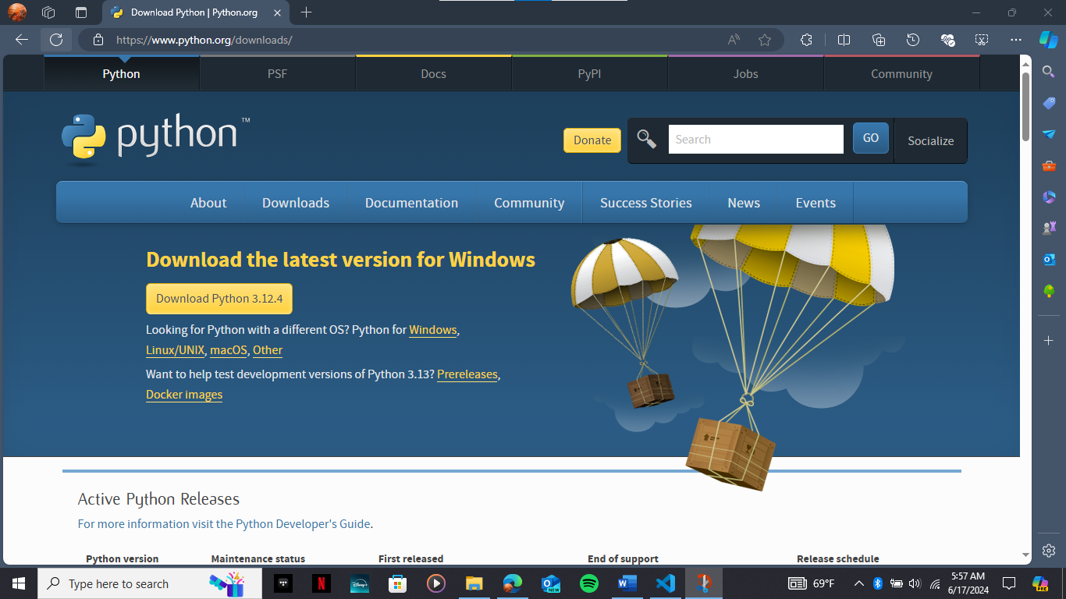

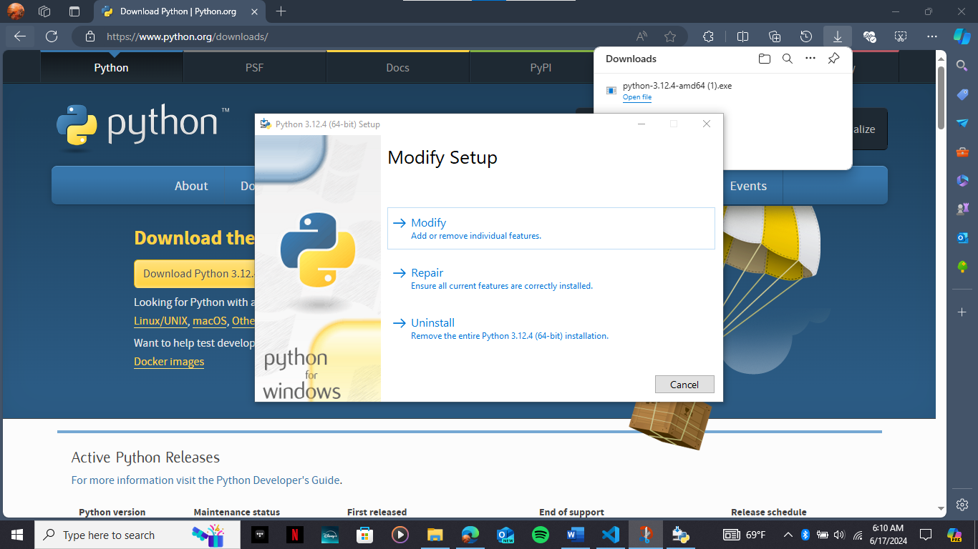

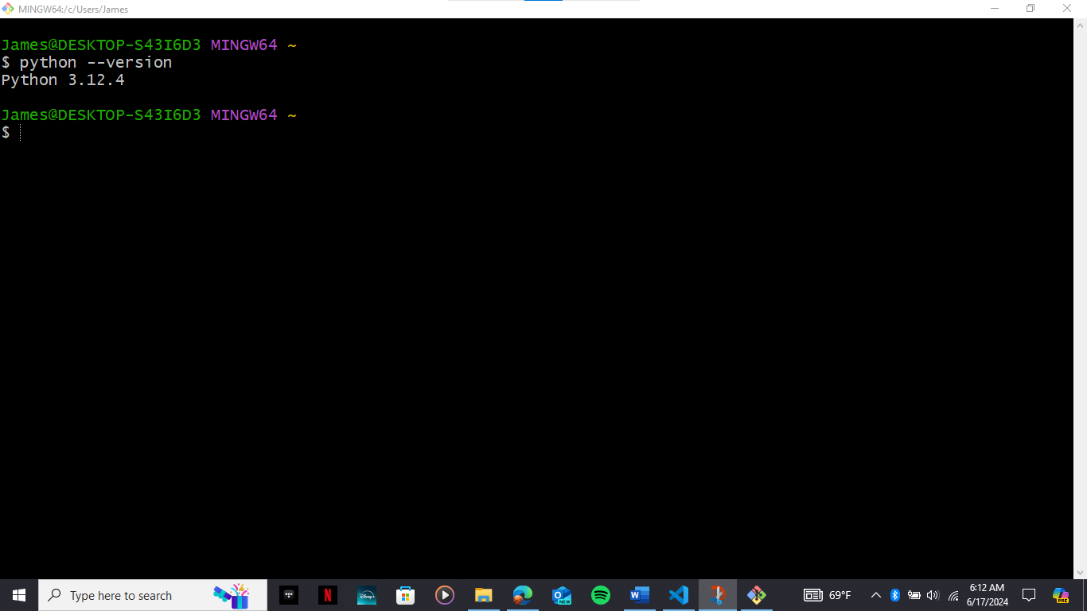

QUESTION 5

To install package managers like pip (Python), follow these steps:

Installing pip on Windows

1. **Method 1: Using `get-pip.py`**

- Download the `get-pip.py` file using the following command:

```bash

curl https://bootstrap.pypa.io/get-pip.py -o get-pip.py

```

- Run the following Python command to install pip:

```bash

python get-pip.py

```

- Verify the installation by running:

```bash

python -m pip help

```

- Add pip to the system's PATH environment variable:

- Open the Start menu, search for "Environment Variables," and press Enter.

- Click the "Environment Variables" button.

- Double-click the "Path" variable to edit it.

- Select "New" and add the directory where pip is installed.

- Click "OK" to save the changes.

2. **Method 2: Using `ensurepip`**

- Run the following command to install pip:

```bash

python -m ensurepip --upgrade

```

- Verify the installation by running:

```bash

pip --version

```

Checking if pip is installed

- Run the following command to check if pip is installed:

```bash

pip --version

```

### Managing Packages

- Install a package:

```bash

pip install [package_name]

```

- Upgrade a package:

```bash

pip install --upgrade [package_name]

```

- Remove a package:

```bash

pip uninstall [package_name]

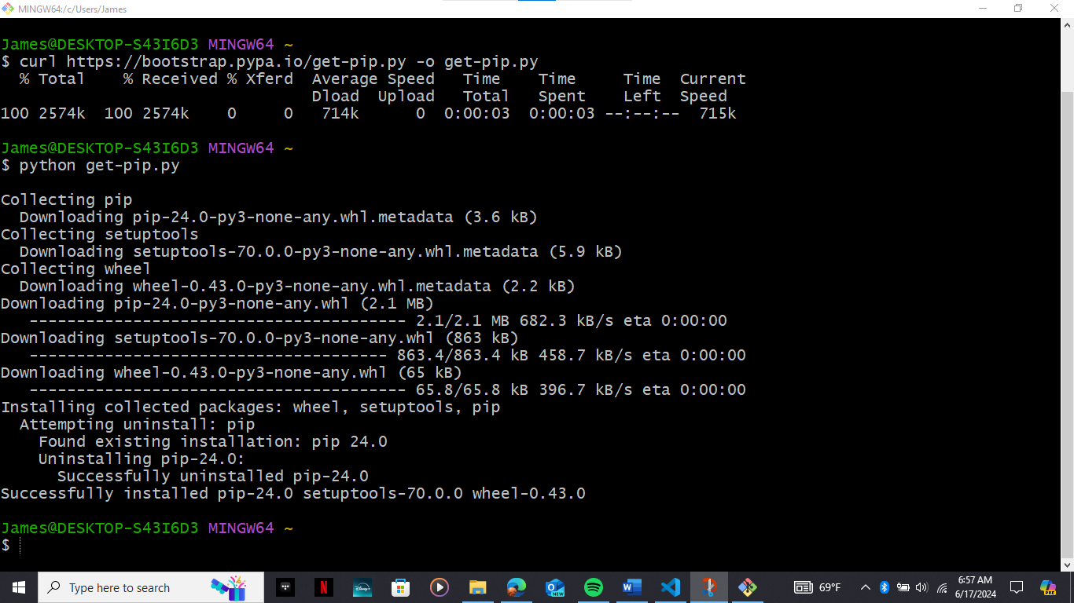

QUESTION 6

To configure a database using my SQL follow these steps to download and install my SQL:

1.Visit the official my SQL website open your preferred web browser and navigate to the official my SQL website at https dev MySQL com downloads windows installer or Mac and Linux.

2. Choose the right file if you have an online connection while running the MySQL installer choose the MySQL installer web community file if you do not have an online connection choose the MySQL installer community file.

3 Ru.n the installer downloads the chosen file and runs the installer to configure my SQL server.

4. Choose the setup type in the first step of the installation process choose the setup type for most users the developer default is suitable.

5. Download and install files the installer will download and install the necessary files this step may take some time.

6. Install my SQL server once the files are downloaded the installer will install my SQL server this step may also take some time.

7. Configure my SQL server after the installation is complete you will be prompted to configure my SQL server, high availability choose the standalone my SQL server option for a single server setup.

8. Type and networking define the port my SQL server is listening on and set additional logging options if needed.

9. Authentication method choose the recommended use strong password authentication option accounts and roles enter a strong password for my SQL root user and create additional roles if needed on Windows service.

10. Final steps:

(a) Start my SQL server start my SQL server by clicking next and then execute in the installer (b) Verify installation open the my SQL command line client or my SQL workbench to verify the installation log in using the root user credentials set during installation.

(c) Create a database and open my SQL workbench open my SQL workbench which is available in your start menu.

(d) Connect to the server connect to the server using the root user credentials set during installation.

(e) Create a database use the create database option in my SQL workbench to create a new database

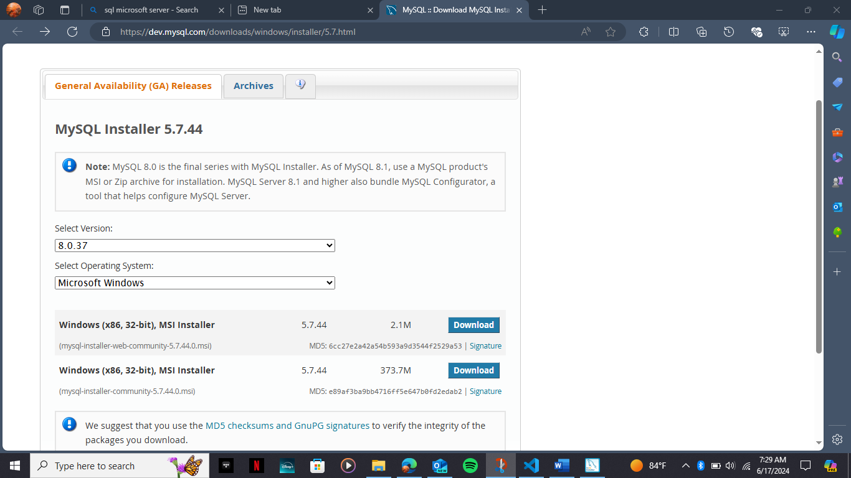

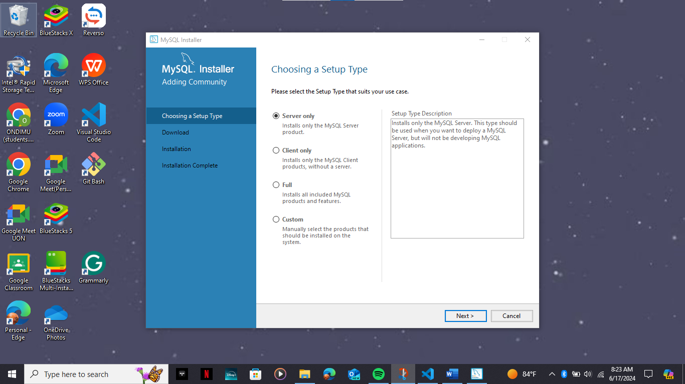

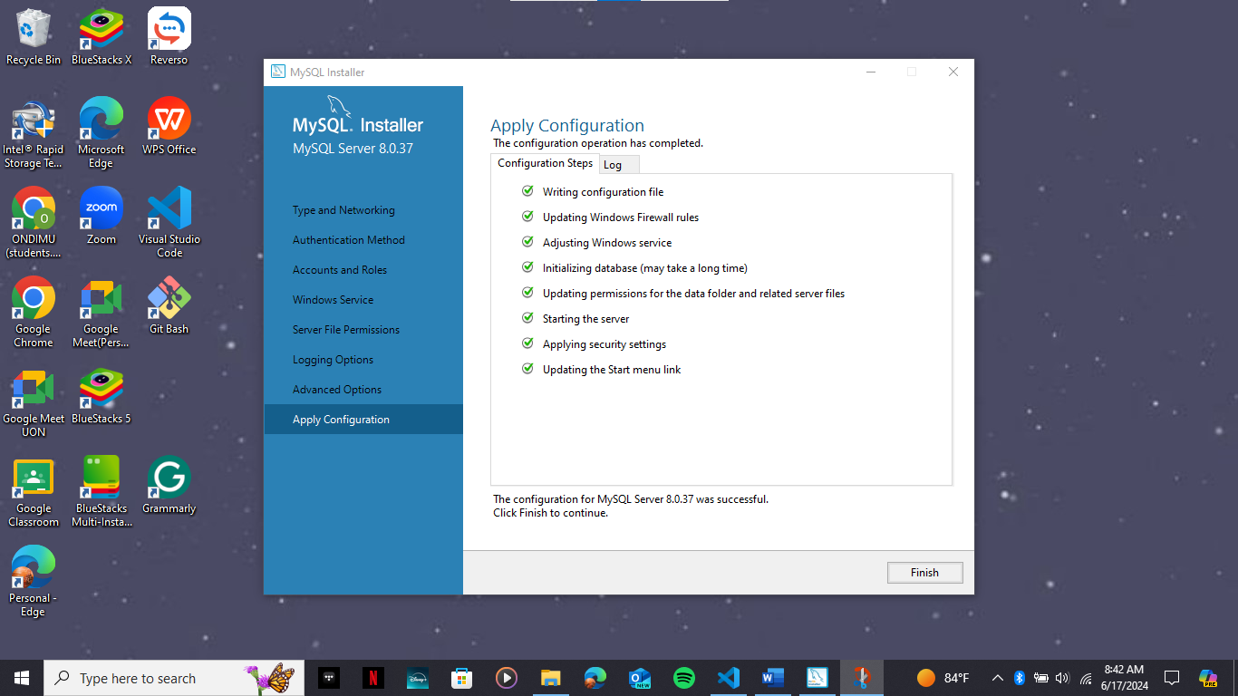

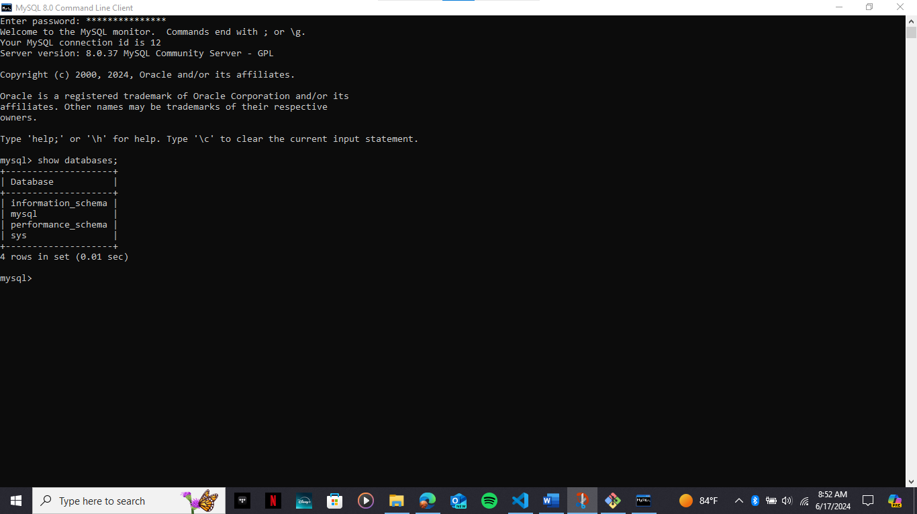

QUESTION 7

Virtualization is a powerful tool for setting up consistent and isolated development environments. Here are the key benefits of using virtualization in software development consistent environments:

1. Virtualization allows developers to create identical development environments that can be easily replicated across different machines this ensures that code behaves the same way regardless of the developer's local setup.

2 Flexibility and isolation virtual machines and containers provide a high degree of isolation allowing developers to run different operating systems software versions and dependencies without conflicts

3.Reduced setup time virtualized development environments can be quickly provisioned and configured saving time for new developers joining a project

4. Cost savings virtualization reduces the need for dedicated hardware as multiple virtual environments can run on a single physical machine 1 2

5. Testing and debugging virtualized environments enable easy testing of new features or configurations without impacting the production system

Based on the search results some popular virtualization options for software development include virtual machines v ms using hypervisors like oracle vm v mware or virtual box. Container-based virtualization using tools like docker or podman .

When choosing a virtualization approach consider factors like the level of isolation required support for specific software hardware and the trade-offs between resource efficiency and ease of management. Ultimately virtualization can greatly improve the consistency and productivity of your development workflows.

QUESTION 8

To explore extensions and plugins for your chosen text editor or ide follow these steps:

1. Identify the editor or ide and determine which text editor or ide you are using such as sublime text visual studio code vs code or visual studio.
2. Check official repositories visit the official repositories for your chosen editor or ide to see the available extensions and plugins for example sublime text sublime text package control visual studio code.
3. Visual studio extensions search for extensions and plugins, use the search functionality within the editor or ide to find specific extensions or plugins, for example in vs code you can search for extensions in the extensions panel by typing a keyword or description in the sublime text you can use package control to search for packages. Explore categories and features browse through the available extensions and plugins categorize them by functionality such as syntax highlighting linting code formatting version control integration debugging tools productivity enhancements, read reviews and ratings check the reviews and ratings for each extension or plugin to gauge their effectiveness and popularity install and test install the chosen extensions or plugins and test them to ensure they meet your needs.
4. Community support , join online communities or forums related to your chosen editor or ide to ask questions and get help from other users who have experience with the extensions and plugins by following these steps you can effectively explore and utilize extensions and plugins to enhance the functionality of your chosen text editor or ide.

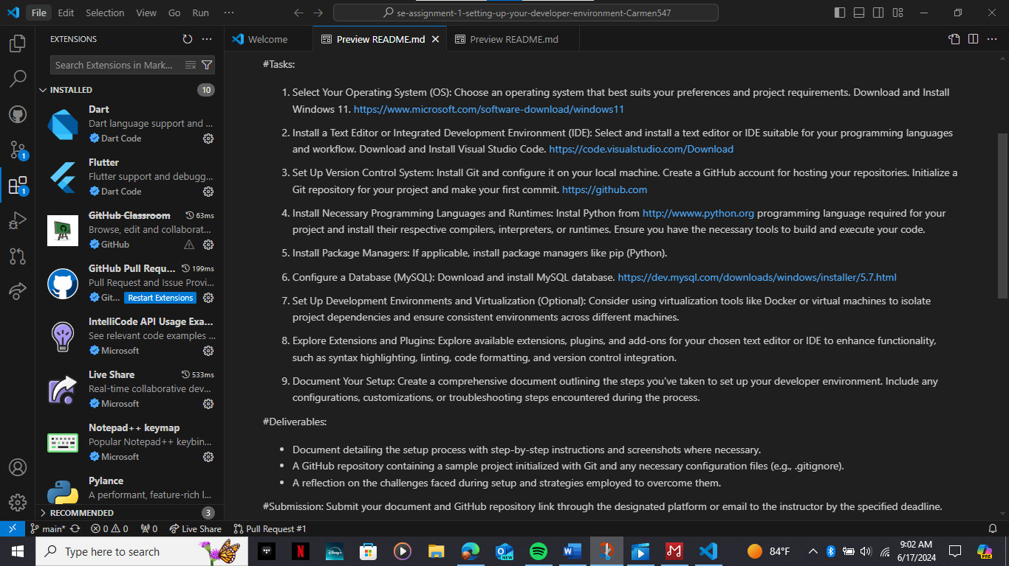

* **A GitHub repository containing a sample project initialized with Git and any necessary configuration files (e.g., .gitignore).**
* 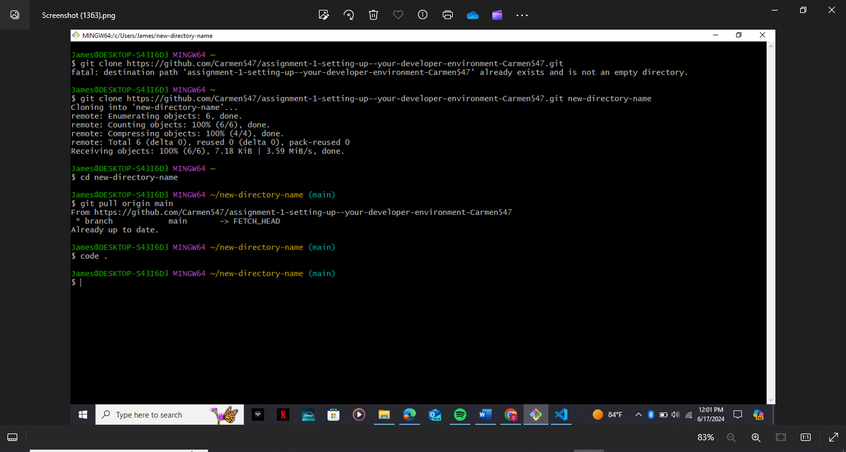

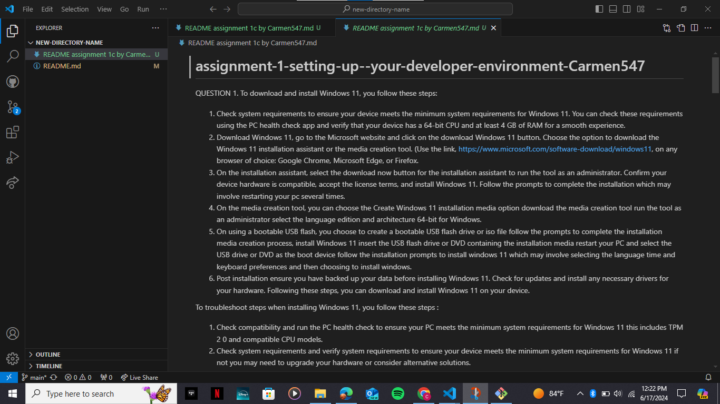

<https://github.com/Carmen547/assignment-1-setting-up--your-developer-environment-Carmen547.git>,